Lab -2 – Task:
Reg.No : AP25110010807
Name : S.Jignesh

Question 1:

Algorithm 1:
Code :
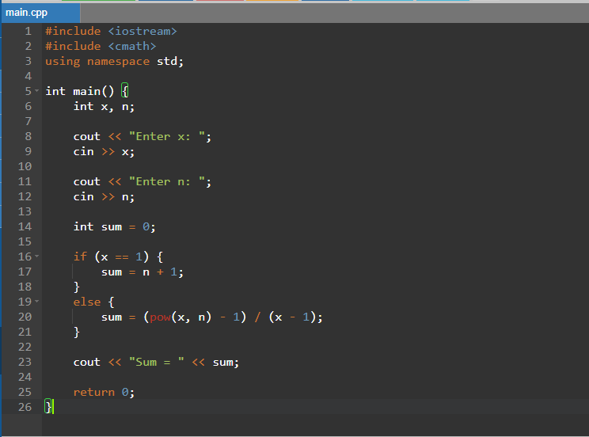
Output:
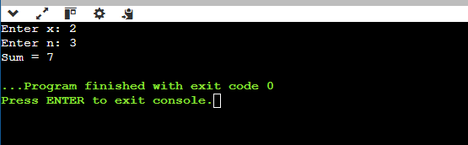

Algorithm 2:
Code:
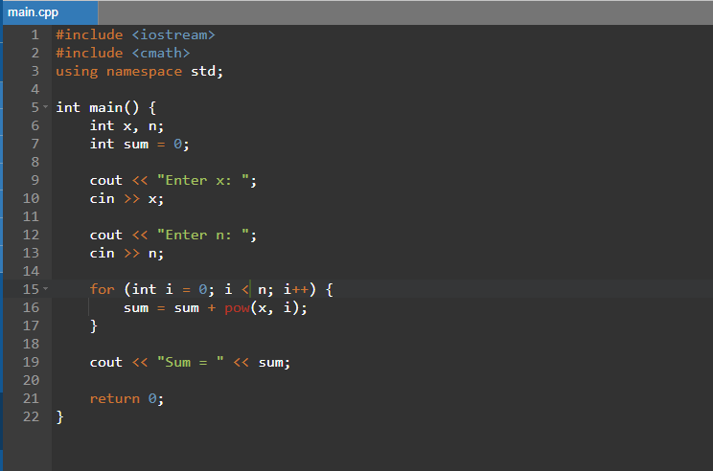
Output:
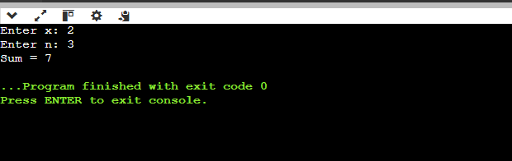

Question 2:

Algorithm 1:
Code:
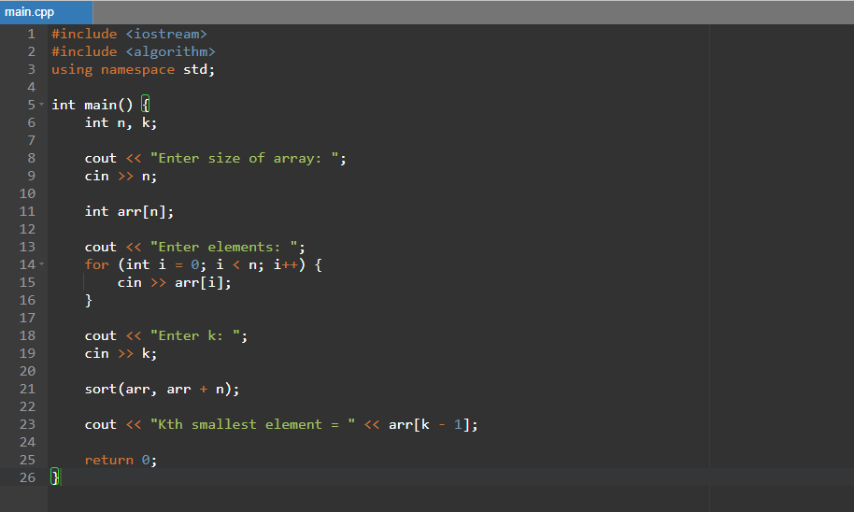
Output:
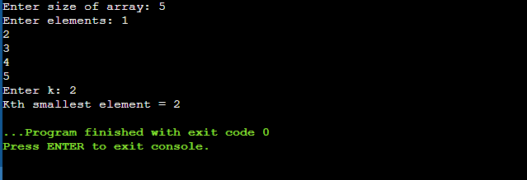

Algorithm 2:
Code:
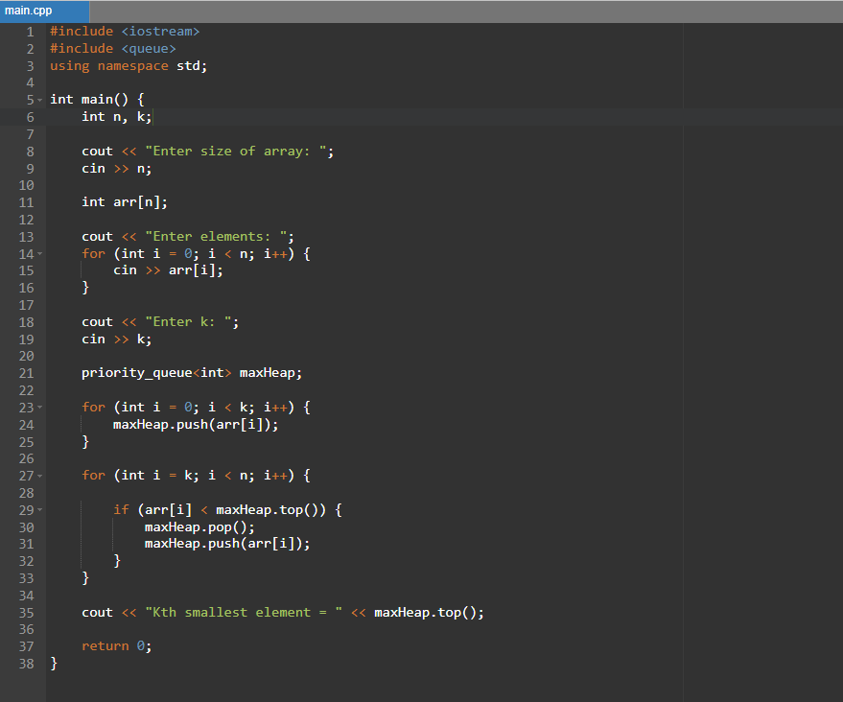
Output:
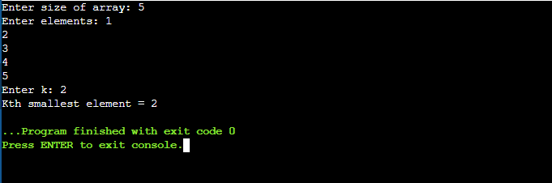

Question 3:

Code:
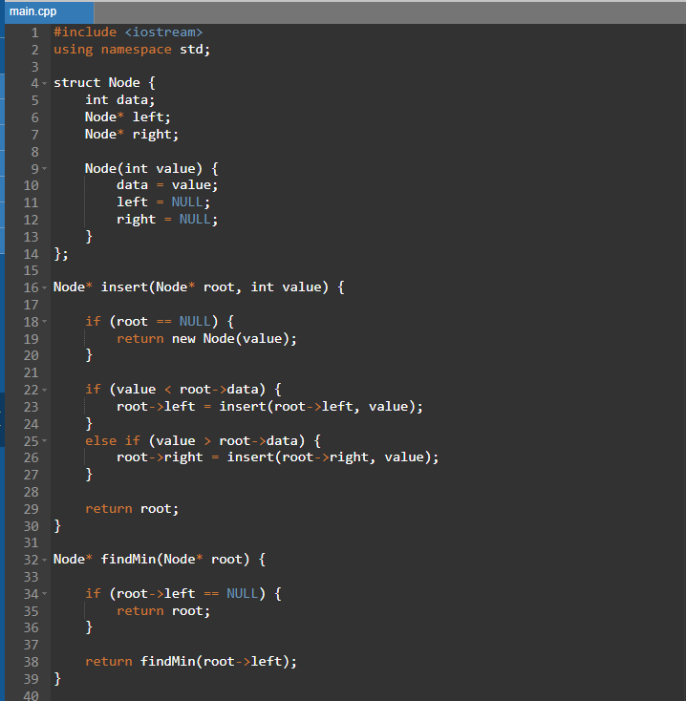
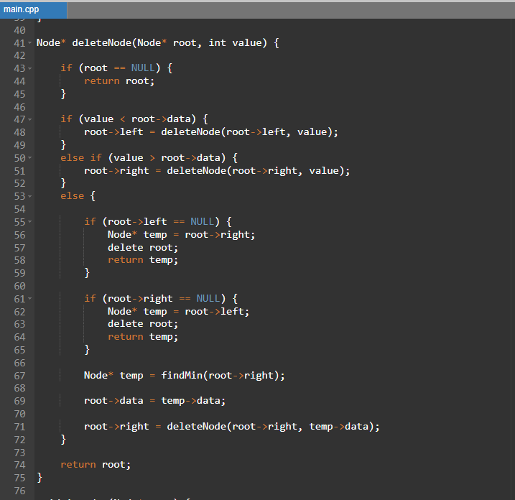
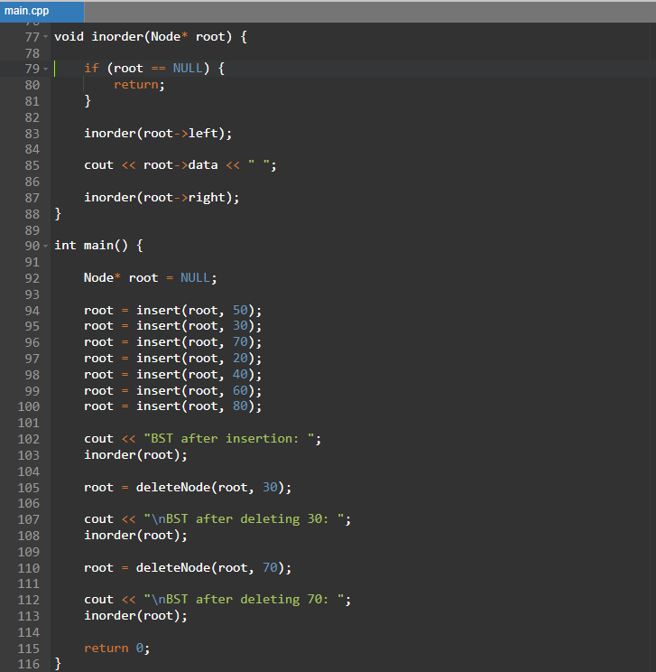

Output:
